DBMS EXP 5

1.Create a query to display the last name and salary of employees earning more than 12000. 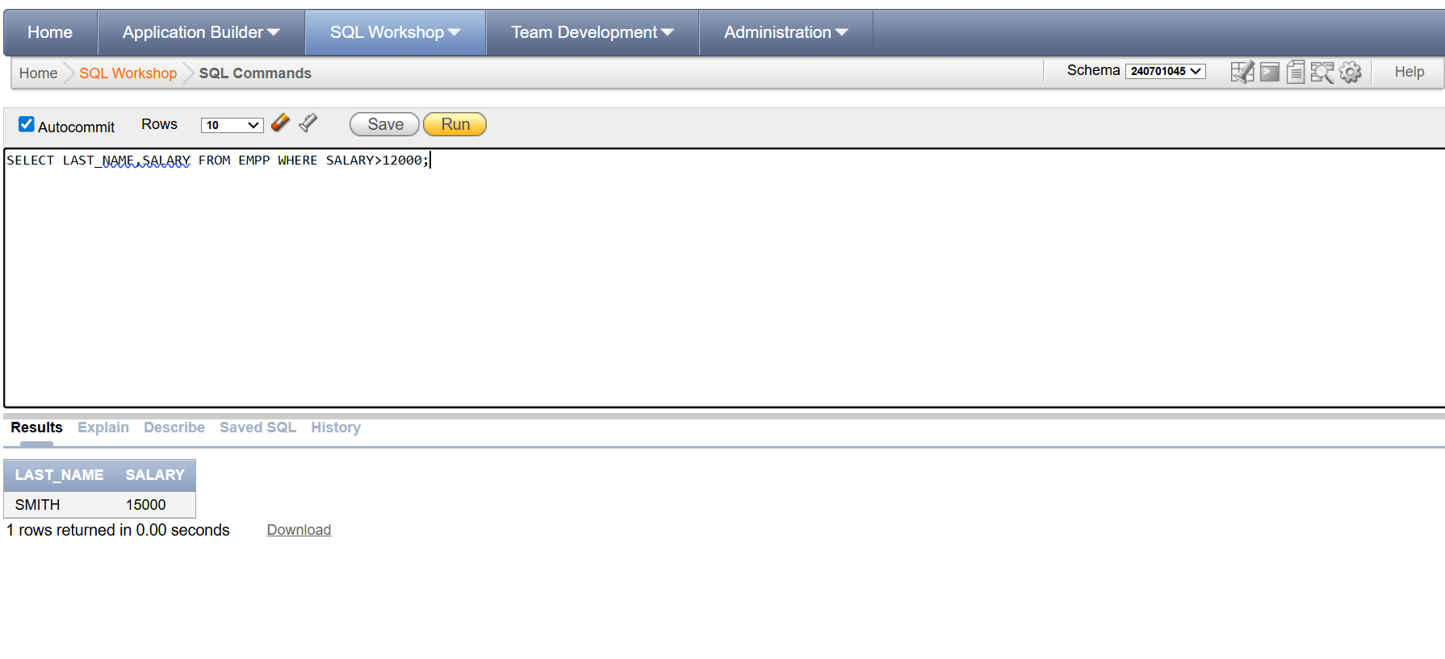

2.Create a query to display the employee last name and department number for employee number 176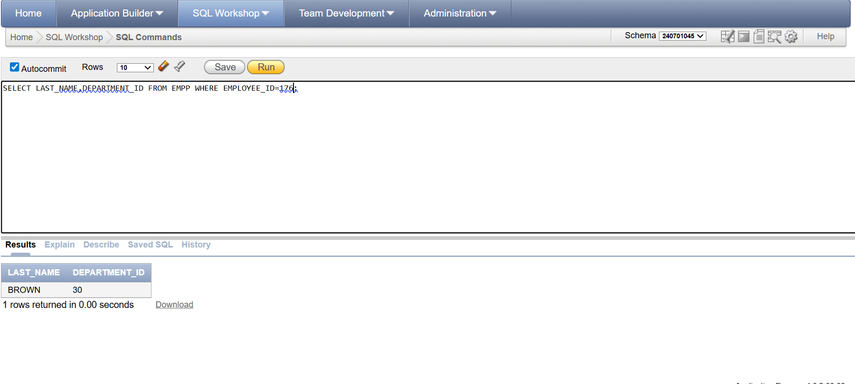

3.Create a query to display the last name and salary of employees whose salary is not in the range of 5000 and 12000. (hints: not between )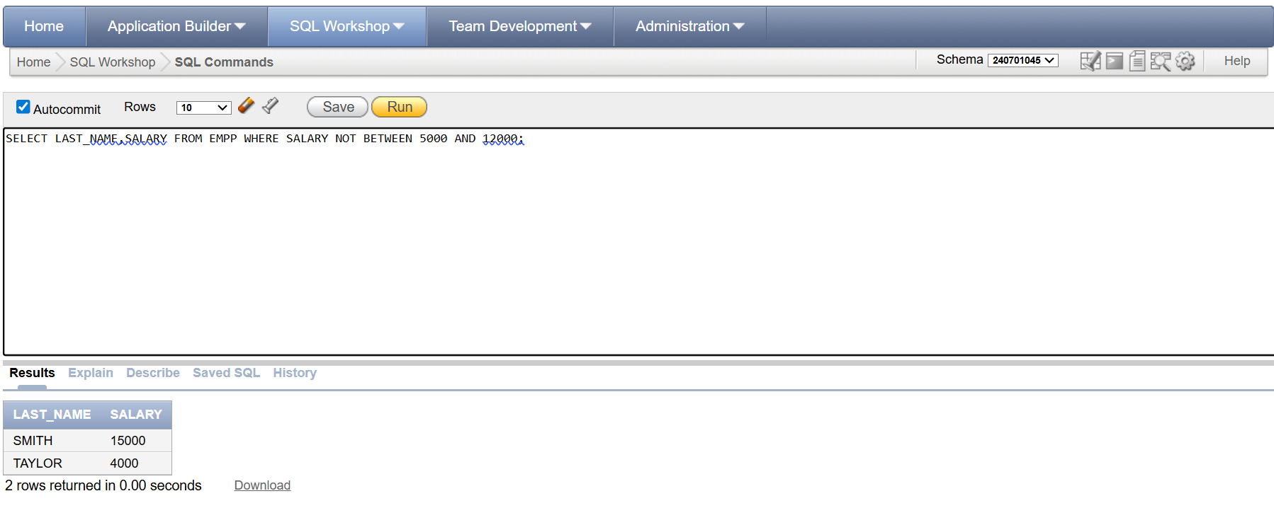

4.Display the employee last name, job ID, and start date of employees hired between February 20,1998 and May 1,1998.order the query in ascending order by start date.(hints: between) 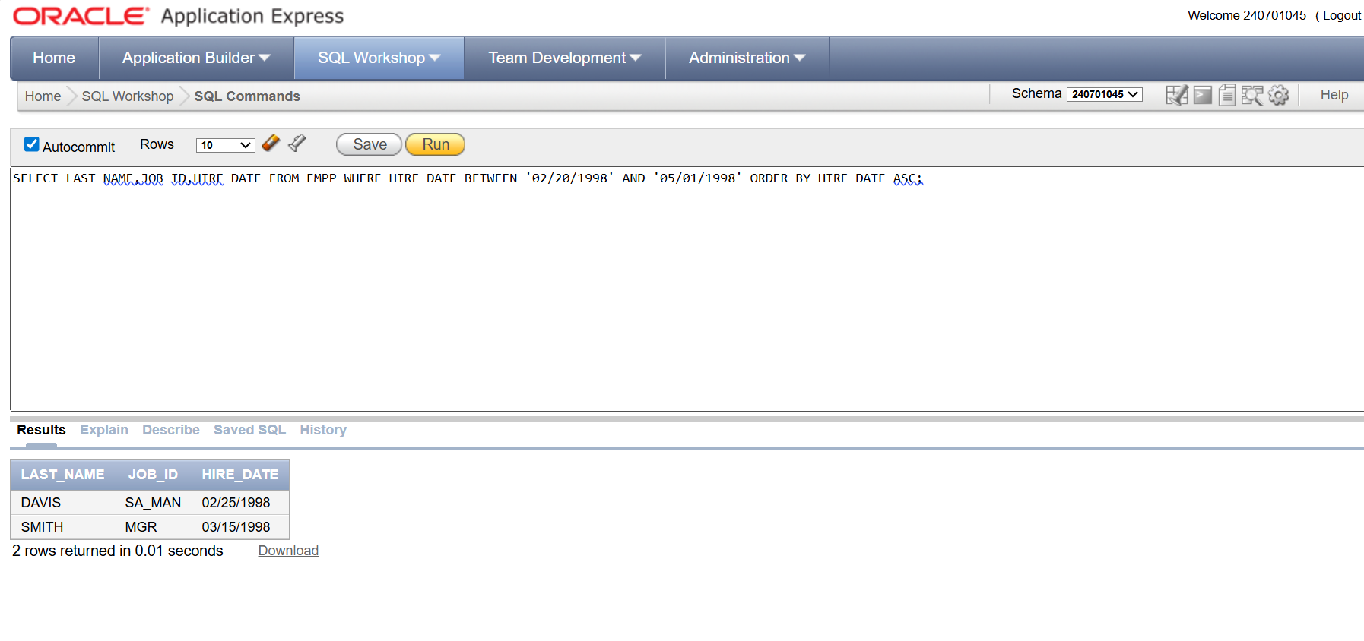

5.Display the last name and department number of all employees in departments 20 and 50 in alphabetical order by name.(hints: in, orderby)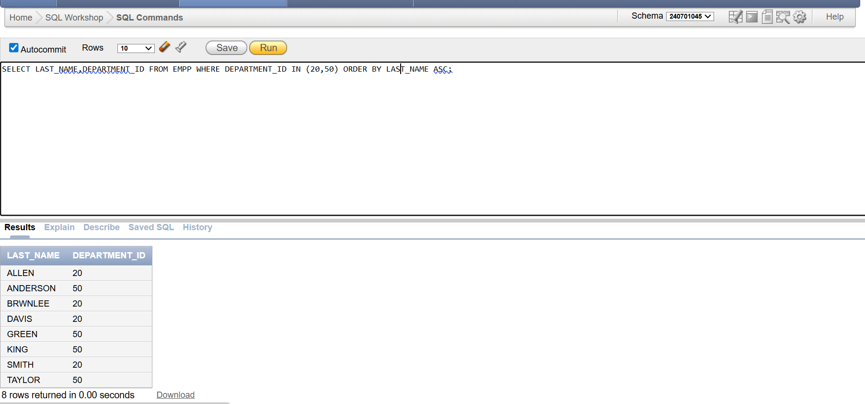

6.Display the last name and salary of all employees who earn between 5000 and 12000 and are in departments 20 and 50 in alphabetical order by name. Label the columns EMPLOYEE, MONTHLY SALARY respectively.(hints: between, in)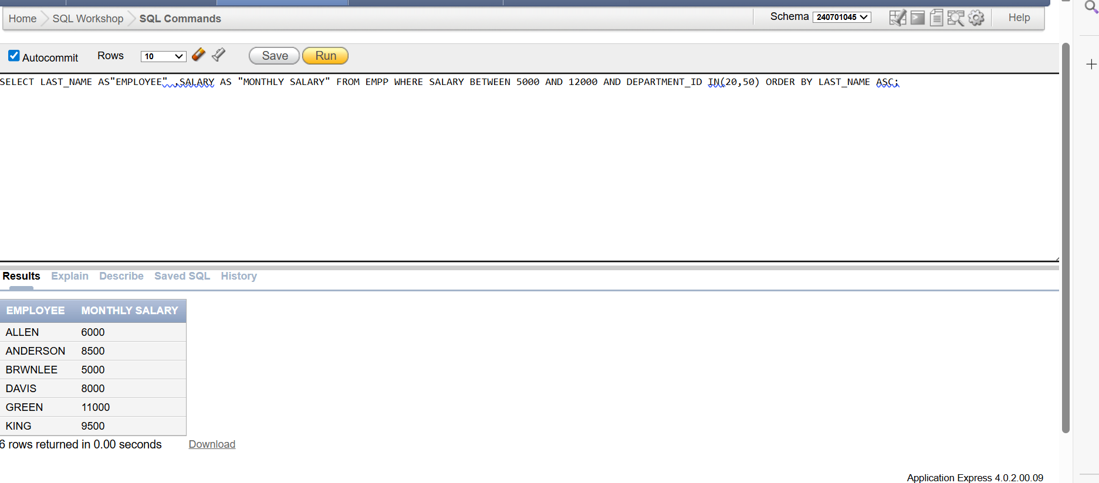

7.Display the last name and hire date of every employee who was hired in 1994.(hints: like)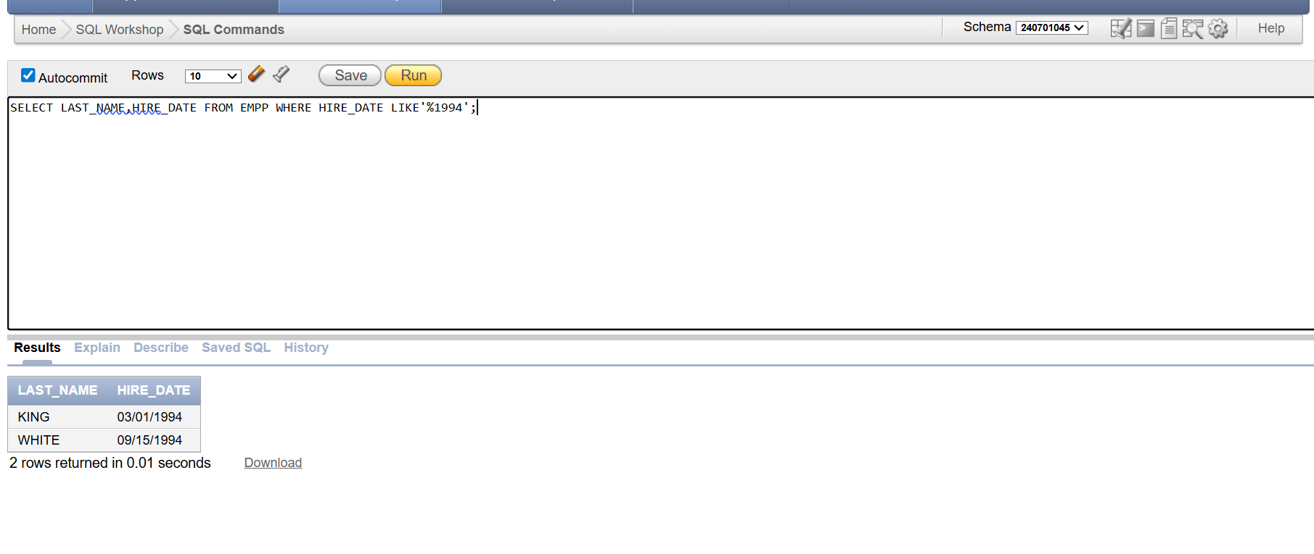

null) 8.Display the last name and hire date of every employee who was hired in 1994.(hints: like) Display the last name and job title of all employees who do not have a manager.(hints: is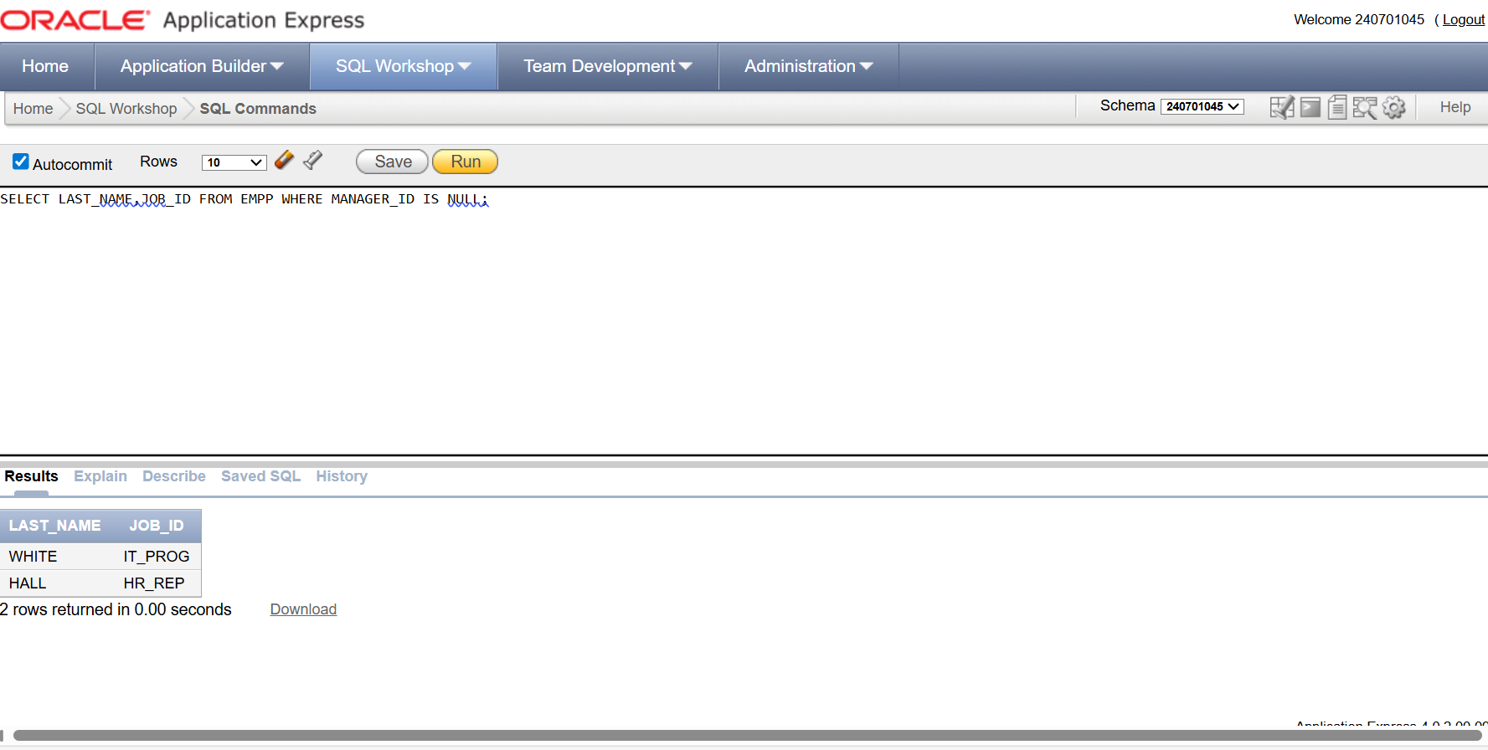

9.Display the last name, salary, and commission for all employees who earn commissions. Sort data in descending order of salary and commissions.(hints: is not nul,orderby)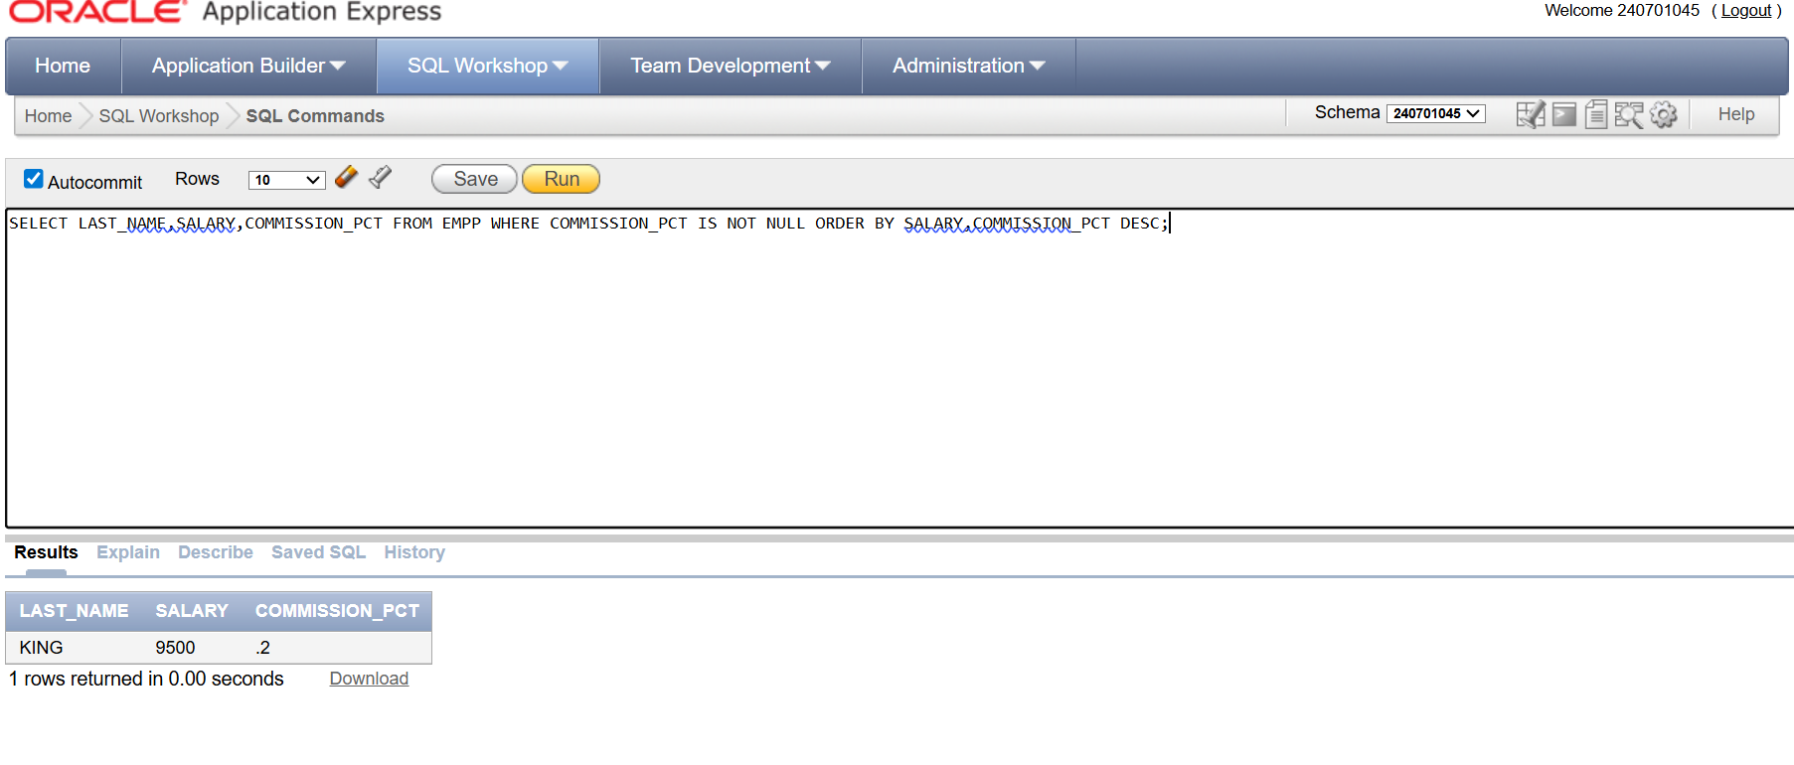

10.Display the last name of all employees where the third letter of the name is a.(hints:like) 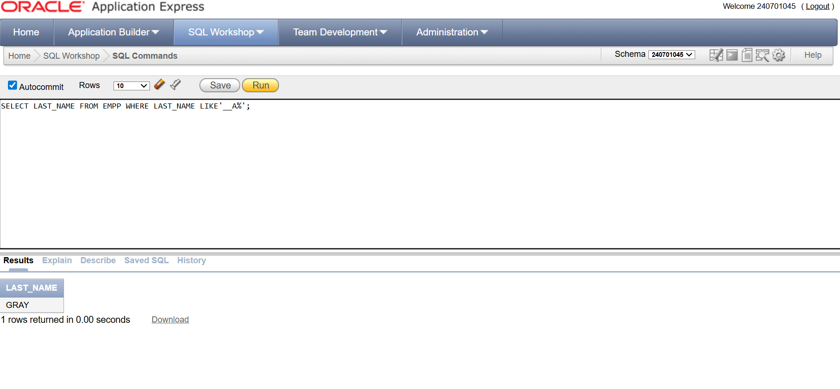

11.Display the last name of all employees who have an a and an e in their last name.(hints: like) 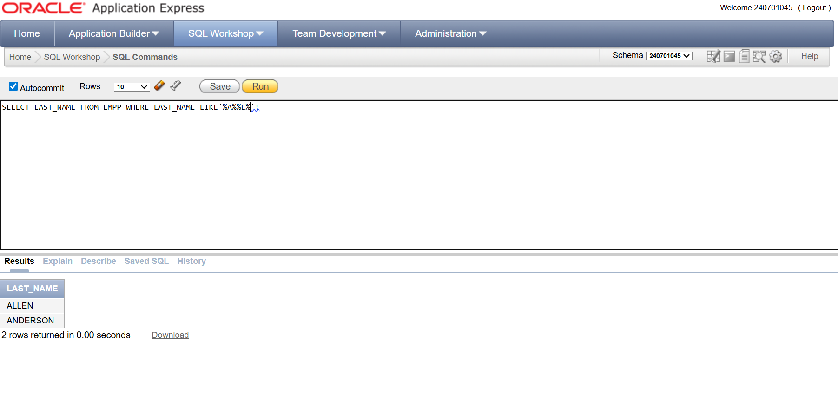

12.Display the last name and job and salary for all employees whose job is sales representative or stock clerk and whose salary is not equal to 2500 ,3500 or 7000.(hints:in,not in) 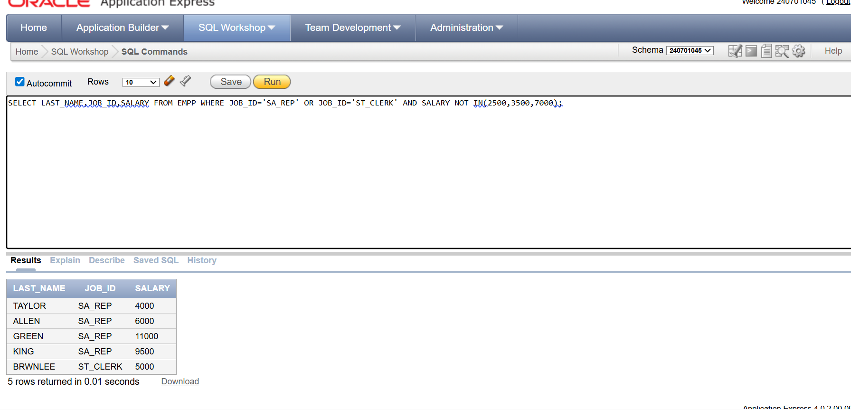

13.Display the last name, salary, and commission for all employees whose commission amount is 20%.(hints:use predicate logic)